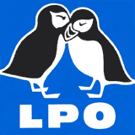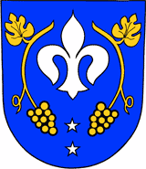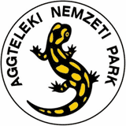
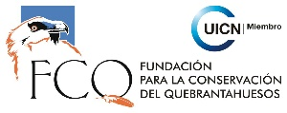

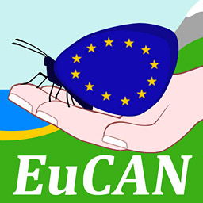

EUROPEAN CONSERVATION ACTION NETWORK
EuCAN Community Interest Company

Expression of interest form 2026

- Your Name ……………………………………………….Mr/Mrs/Ms/……..

- Date of Birth …………………………………………………..

- Postal Address with postcode:

- Email address:

- Contact phone numbers:
  - Daytime:
  - Evenings:
  - Mobile:

- Do you have any special dietary requirements? …………..

- If you are a vegetarian , please indicate whether you eat
        - Fish?
        - Eggs?
        - Cheese?

- Present occupation:

- Can you tell us how you found out about this project?

- If you are not employed in conservation, what conservation volunteering have you done

Please write a few lines below to describe your involvement with or interest in wildlife conservation at present and to express what you would expect to get out involvement with EuCAN CIC. Also, if you feel you have particular qualifications/skills or could make a contribution that would be especially valuable to the project, please tell us.
Please note that you do not have to have had any previous involvement in environmental volunteering to qualify for a EuCAN placement or training but we would expect you to be looking for ways to make a contribution locally – please contact us if you would like advice on this….

Please return completed forms by email as word attachments to nigelspring@yahoo.co.uk. Please do not send in postal applications.

For further information, please visit: www.eucan.org.uk
Contact: Nigel Spring Tel: 07981.776767
Email: nigelspring@yahoo.co.uk.

The aims of EuCAN CIC are
- to encourage and facilitate cultural exchange and the exchange of environmental ideas and skills between the UK and other countries (particularly within the European Union).
- to promote practical conservation volunteering both in the UK and abroad
- to promote the conservation of the physical and natural environment by promoting biodiversity.
- to encourage sustainable development in the rural economy through environmentally sensitive farming and food production.
- to promote the research and development of systems of conservation management and agriculture which are both economically viable and environmentally sustainable.
- to provide education and training related to these activities and to disseminate relevant information and guidance to the public at large.
www.eucan.org.uk

EuCAN CIC is registered in England and Wales as a Community Interest Company limited by guarantee.
Registered Company no. 7513162. Registered Office: 346, Mundens Lane, Alweston, Sherborne, Dorset DT9 5HU.

