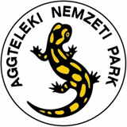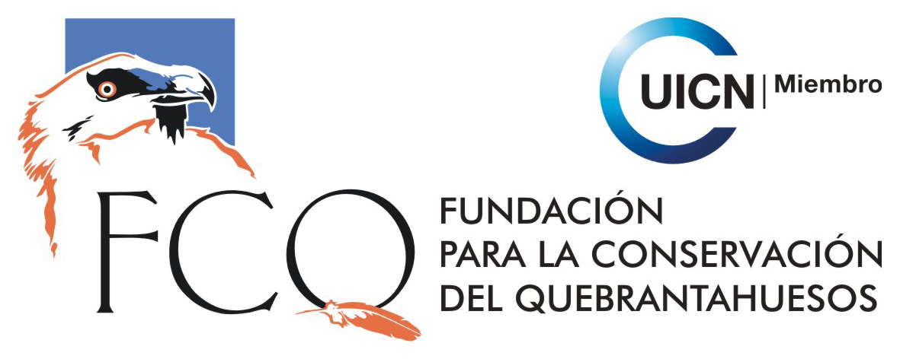

EUROPEAN CONSERVATION ACTION NETWORK
EuCAN Community Interest Company

SELECTION PROCEDURE FOR EUROPEAN PLACEMENTS 2014

We have drawn up a selection procedure to ensure that the groups of participants are balanced and include people from our main target groups, rather than allocating places on a first come, first served basis. This may mean that some of the groups will not be completely filled until we are satisfied that the quota for each target group has been met as far as can be expected. As far as the funding is concerned, it is important that we take the full quota of participants, otherwise the funding may be reduced.

The people eligible for our European placements must be over 21. Some of our other funders may impose different restrictions.

Each group consists of 12 – 15 participants with the two leaders.
- In a group of 13, we would look for a gender balance, certainly no less balanced than 8-5.
- We would look for an age balance, so that the number over 35 as far as possible balances the number under 35, certainly no less balanced than 8-5.
- Our particular target groups are unemployed adults and 21-35 year olds not involved in environmental conservation.
- We are particularly keen to target groups that might be described as ‘marginalized’, including people with mental health problems, ex-offenders, people sentenced to do community service hours. We would aim to take 1 or 2 people in this category with each visit.
- In connection with d. we would aim to take one person in each group who might be classed as a ‘carer’, who would require crb clearance for working with vulnerable adults.
- Of the 13, we would hope that one person might belong to an ethnic minority group.
- People over pension age are still considered to be part of the ‘labour market’ and we would hope to take one person over 60 with each group.
- We would hope to include at least one certificated chainsaw user and three brushcutter users in each group.
Nigel Spring January 2014

The aims of EuCAN CIC are
- to encourage and facilitate cultural exchange and the exchange of environmental ideas and skills between the UK and other countries (particularly within the European Union).
- to promote practical conservation volunteering both in the UK and abroad
- to promote the conservation of the physical and natural environment by promoting biodiversity.
- to encourage sustainable development in the rural economy through environmentally sensitive farming and food production.
- to promote the research and development of systems of conservation management and agriculture which are both economically viable and environmentally sustainable.
- to provide education and training related to these activities and to disseminate relevant information and guidance to the public at large.
www.eucan.org.uk

EuCAN CIC is registered in England and Wales as a Community Interest Company limited by guarantee.
Registered Company no. 7513162. Registered Office: 346, Mundens Lane, Alweston, Sherborne, Dorset DT9 5HU.

