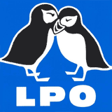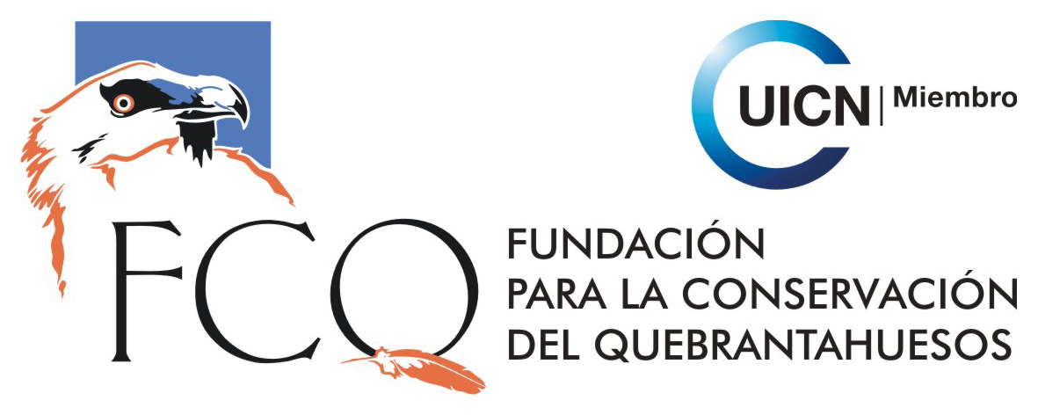

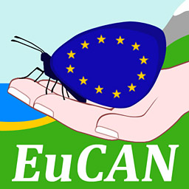

EUROPEAN CONSERVATION ACTION NETWORK
EuCAN Community Interest Company

Expression of interest form 2015

- Your Name ……………………………………………….Mr/Mrs/Ms/……..

- Date of Birth …………………………………………………..

- Postal Address with postcode:

- Email address:

- Contact phone numbers:
  - Daytime:
  - Evenings:
  - Mobile:

- Do you have any special dietary requirements? …………..

- If you are a vegetarian , please indicate whether you eat
        - Fish?
        - Eggs?
        - Cheese?
(Please note that we do not have much scope for flexibility in the catering particularly where it is being done for us. Most European countries tend not to cater for non-carnivorous diets. Omelettes seem to appear with great regularity for vegetarians!)

- Present occupation:

- Can you tell us how you found out about this project?

- Which year did you first apply for a EuCAN placement? …………

- If you are not employed in conservation, what conservation volunteering have you done

Time off
Taking nearly three weeks off for EuCAN placements has proved to be a problem for some people unless the employers treat it as training (which it is!) rather than holiday. Some organisations have allowed participants a proportion of their time away as training.

- If you are in employment, do you anticipate that you will be able to take the time off for a EuCAN placement and if so, will this be regarded as paid holiday or training? Or a mixture of the two?................................................................................................................
Payment for the EuCAN visits
Up to now the EuCAN placements have been free (but extremely expensive nevertheless). One idea we have had is to ask conservation organisations to contribute towards the cost of the placements for their own volunteers as part of their training programmes, in the same way as they might contribute towards the cost of a chainsaw course as part of their investment in the volunteer.
- If you are a regular volunteer for a conservation organisation, do you think the organisation would be prepared to contribute a small part of the placement costs, say, £150? It might be worth asking – it is something we would like to develop. Let us know what you think………………………………………………………………………………………...

Selection Procedure (see our website for further details)
We try to select balanced groups for each placement and to choose participants who are likely to benefit the most from the experience. Could you indicate which of these descriptions apply to you:
- 60 years old or over.
- 50-60 years old, retired from fulltime work.
- 21-35 years old.
- Over 35.
- Graduate from tertiary education
- Involved in environmental conservation as a volunteer.
- Involved in environmental conservation as an employee.
- Not yet involved in environmental conservation either as a volunteer or an employee.
- Involved in agriculture, food production, grazing schemes etc – specify…………….
……………………………………………………………………………………………
- Unemployed.
- Ethnic minority.
- Trained chainsaw user.
- Trained brushcutter user.
If you are a trained brushcutter or chainsaw user, you will be expected to use these power tools on the placement and to provide your own protective trousers and boots (we provide the machines and helmets).
- If you would be interested in brushcutter training during a EuCAN weekend, please tick.

Please write a few lines below to describe your involvement with or interest in wildlife conservation at present and to express what you would expect to get out of a EuCAN placement. Also, if you feel you have particular qualifications/skills or could make a contribution that would be especially valuable to the project, please tell us.
Please note that you do not have to have had any previous involvement in environmental volunteering to qualify for a EuCAN placement or training but we would expect you to be looking for ways to make a contribution locally – please contact us if you would like advice on this….

Please return completed forms by email as word attachments to nigelspring@yahoo.co.uk. Please do not send in postal applications.

For further information, please visit: www.eucan.org.uk
Contact: Nigel Spring Tel: 01963.23559 Mobile: 07981.776767
Email: nigelspring@yahoo.co.uk.

The aims of EuCAN CIC are
- to encourage and facilitate cultural exchange and the exchange of environmental ideas and skills between the UK and other countries (particularly within the European Union).
- to promote practical conservation volunteering both in the UK and abroad
- to promote the conservation of the physical and natural environment by promoting biodiversity.
- to encourage sustainable development in the rural economy through environmentally sensitive farming and food production.
- to promote the research and development of systems of conservation management and agriculture which are both economically viable and environmentally sustainable.
- to provide education and training related to these activities and to disseminate relevant information and guidance to the public at large.
www.eucan.org.uk

EuCAN CIC is registered in England and Wales as a Community Interest Company limited by guarantee.
Registered Company no. 7513162. Registered Office: 346, Mundens Lane, Alweston, Sherborne, Dorset DT9 5HU.

