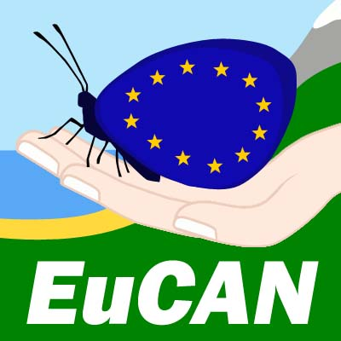

EUROPEAN CONSERVATION ACTION NETWORK
EuCAN CIC

CONSERVATION VISIT TO LA BRENNE, CENTRAL FRANCE

Monday November 21st – Wednesday November 30th 2016

Participant Registration Form

Please complete one form per person
The information will be held in confidence in accordance with the Data Protection Act, and referenced by the leader(s) in case of an emergency whilst on the placement.
We may use your personal details in order to contact you.

Your Details

Title ………. Surname …………………………………………………. Gender…………….

Forename……………………………………… Date of Birth…………………

Address ……………………………………………………………………………….

…………………………………………………………………………………… Postcode…………..

Telephone contact numbers Daytime…………………………….

Evenings…………………………….

Mobile………………………………

Email Address………………………………………………………..

Present Occupation…………………………………………National Insurance No. …………………

Emergency Contact you must give the details of someone we can contact in case of an emergency

Name……………………………………… Telephone no. ……………………………

Emergency Contact email address: ……………………………………………………………..

Relationship to you……………………………………………

GP practice / Tel contact: ………………………………………………………………………..

Participants will receive contact details for other members of the group so that you can travel together. We strongly encourage you to agree to your details being included on this list, but if you do not wish to do so,
please indicate this here…………………………

We would like to be able use the photos from our visits for publicity purposes, website etc. Please indicate here if you do not want photos that include you or that were taken by you to be used in this way …………………….

First Aid Qualifications: ………………………………………….

Certificate Expiry Date …………………..

Power Tools Qualifications
Please list here:………………………………………………………
Have you got your own insurance for using the power tools?...................
Power tools users: please understand that you will be expected to use power tools during your placement and bring your own protective boots and trousers.

Do you hold a PCV Drivers Licence? ……………………………………..Expiry Date………….

Do you have any qualifications in Health and Safety/Risk Assessment/Food Hygiene? ………….
If so, please give details: …………………………………………………………………………………

Diet
Have you any special dietary needs? It should be possible to accommodate some special diets (but no promises, the French tend to be carnivores and omelettes seem to appear with great regularity for vegetarians!)
Are you a vegetarian?...............
Indicate whether you eat Fish……………………………
Cheese………………………….
Eggs……………………………

Language(s) spoken in addition to English ……………………………………..

Health and Fitness considerations
During this visit you will be expected to be fully involved for the full length of the placement and to carry out practical conservation management work for 5 out of the 8 days we are there. This work may well be physically tough (and sometimes in difficult conditions), so it is important that you take care to consider your replies to the following sections.

Please note here any relevant health details eg. allergies, asthma etc. and the sort of work this might prevent you from doing.

……………………………………………………………………………………………………………….

Please note any mental or physical difficulties and any activities these may prevent you from doing.

……………………………………………………………………………………………………………….

To ensure First Aiders are aware of relevant information, please inform us of any medication you are taking

………………………………………………………………………………………………………………..

Tetanus we recommend that you check that your tetanus immunisation is up to date. Please give us the approximate date of your last booster and indicate how many boosters you have had.

Approximate Date:………………………..

Number of Boosters……………………….

Report
Although this visit is not a fully funded placement, we would very much appreciate a report of some sort from you afterwards which can be published on our website and/or in a journal or website that you are involved with. This is very useful for disseminating information about this project and also enables us to assess the benefits of the placement to you and to our organisation.

Money
If you are unable to take up your place and it cannot be filled by someone else, you will forfeit the financial contribution you have made.

Declaration Please sign below

- I have read the briefing and have evaluated my suitability/ability for this visit.
- I feel that I have the appropriate level of fitness and am immunised against Tetanus.
- I am not undergoing any medical treatment that might affect my performance on this placement.
- I will bring all my appropriate medication and will inform the organisers of any changes in my medication between now and the beginning of the placement.
- During the visit, I will notify the leaders of any medical problems and/or symptoms as they occur.
- During the visit I will work safely and under the instruction of the leaders and site supervisors.
- I agree to follow EuCAN policies and procedures when engaged in their projects and activities.
- I understand that any anti-social behaviour that threatens the well-being of the group will result in dismissal from the placement with the loss of any money paid.
- I have read and understood the Risk Analysis for the visit – on the EuCAN website.
- I declare that all the information given by me on this application form is correct.
- I consent to my personal details being used for the purposes described, and shall advise EuCAN of any changes to my circumstances.
- My passport is valid for at least 6 months.
- I have an up-to-date European Health Insurance Card.
- I will take out personal health and belongings insurance cover before the departure date.

Signed ……………………………………………… Print ………………………………….

Date…………………………………………………

Could you complete this registration form and return it by email as soon as possible please to nigelspring@yahoo.co.uk and also post a signed copy of it to
Nigel Spring, 346, Munden’s Lane, Alweston, Sherborne, Dorset DT9 5HU.

