European Conservation Action Network

EuCAN Community Interest Company



Visit to Aggtelek National Park, north-eastern Hungary
Tuesday 5th – Thursday 14th May 2015

Itinerary and log
Friday May 1st
Departed Alweston at 7.30am. Reached Basingstoke railway station at 9.30am where we picked up John and Diana. Reached the earlier ferry from Dover to Calais at 12.55. Disembarked at 3.30pm local time and drove to Beloeil/Stambruges (Junction 27 off E42) to camp at a site called Les Rochers Rouges, arriving at 5.30. Most of the caravans derelict or for sale, small boy driving unregistered car round the campsite, not altogether a very salubrious place! Good meal in local restaurant but it took ages to arrive.

Saturday May 2nd
Departed 7.30am after Nigel had retrieved his binoculars from the cleaner in last night’s restaurant! Drove down the A3 via Köln to Wertheim arriving at the Azur campsite on the banks of the River Main at 4.30pm. There is a bank machine and supermarket in the town within walking distance, and food with bar on site with a very stressed about-to-retire manageress serving very slowly. Lovely views of huge barges taking aggregate and coal towards the Danube. Egyptian Geese on the river and Nightingales singing from the opposite bank, Fieldfares nesting in the trees in the campsite.

Sunday May 3rd
Departed at 8.45am and by 4.30 had arrived at Harold Stumpfer's campsite at Schönbühel beside the Danube east of Melk – in the region of Austria called Wachau, renowned for its apricots and vineyards. Great food, good beer and wonderful apricot schnaps. http://www.tiscover.com/at/guide/64704at,de/objectId,CPS156467at/home.html/
Golden Orioles calling from the opposite bank, the campsite garden full of Tree Sparrows and many other species. We would thoroughly recommend this campsite and restaurant for a short visit or even a longer stay.
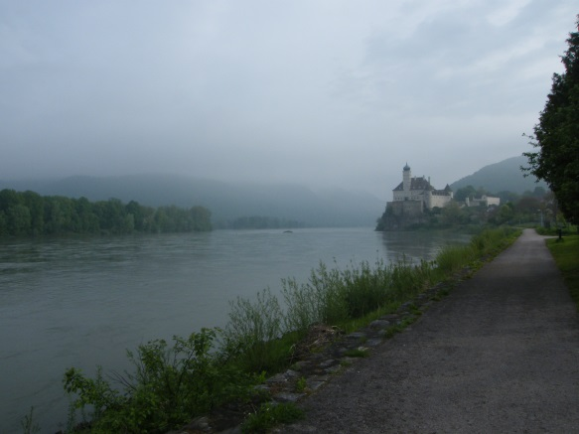
.
Monday May 4th
Departed 8.10am. Entered Hungary and took the new (still under construction!) ringroad round Budapest and the M3 out to Miskolc. Reached Komjati at 5.45pm where to our surprise we met our friends Simon and Dora Hursthouse just outside the gate as we arrived, then our hosts Joszef and Elizabet Szalo and our cooks Eszter and Dia. We were serenaded by a chorus of at least 4 Nightingales, Golden Orioles, frogs in the millpond and Mole Crickets in the surrounding ground. Eszter and Dia produced a delicious Hungarian supper for us.

Tuesday May 5th
We took John and Diana to Torneszantandras and left them to wander homewards while we drove to Budapest to collect 8 of the group. Owing to incorrectly labelled trains and a German rail strike our people were somewhat delayed but arrived (six hours late!) in fine spirits despite not travelling on the sleeper train. We returned to Komjati in time for supper and found the rest of the group had arrived and had already found their guest house in Tornaszentandras. John and Diana were full of stories about the wonderful things they had seen on the walk round Tornaszentandras and back.
Their butterfly sightings included: Scarce Swallowtail, Swallowtail; Knapweed, Pearl-bordered and Heath Fritillaries, Short-tailed Blue (the only one of the trip it seems, all the others were Eastern Short-tailed Blues), the spring (levana) form of the Map, Sooty Copper, Woodland Ringlet, and the strange relative of the Bagworm moths, Pentophora morio with its semi-translucent wings).
Nigel put the moth trap out overnight.

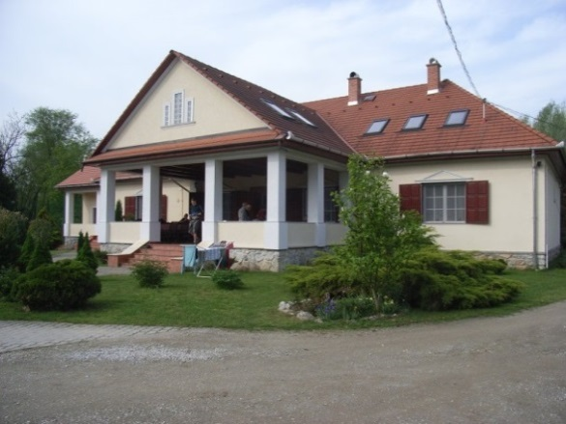
Wednesday May 6th
Before breakfast we went through the moth catch – 50 species was a pretty good haul especially as the night had been quite cold and the moon full. They included several scarce or absent from Britain.
E.g. Silver Cloud, Rosy Marbled, Dingy Shell, Dingy Mocha, Ringed Carpet, Tawny Prominent, Silver Barred, Feathered Ear, and the Geometrid moth fairly widespread in Europe Ascotis selenaria.
Midmorning we drove to Jósvafő and walked up the track from the village into the limestone hills. We saw lovely flowers including Yellow Pheasant's Eye, Purple Gromwell, Lesser Honeywort, Nonea and Birds Nest Orchid and a young Fire Salamander.
We had a picnic lunch beside the ford admiring the butterflies that had congregated on the mud and then bought ice-creams from the kiosk in the village. We saw several of the huge Stonefly Perlodes sp and a mating pair of the large stripy Rove beetles called Staphylinus erythopterus.
New butterfly species included Chequered, Grizzled and Safflower Skippers, the lovely Chequered Blue, Duke of Burgundy, and several Small Eggar, Eriogaster lanestris, larval webs.
Then we drove up the hill to Tengerszem and walked through the woods back into Jósvafő. We found Fire Salamanders beside the streams and amongst many other things had wonderful sightings of two Camberwell Beauty butterflies. There was also a Water Scorpion Nepa in one of the pools and plenty of the damselfly Calopteryx splendens.
Andras Sabadfalvi, known to us as the hermit, arrived in the evening and put up a light and sheet to attract moths

Thursday May 7th
A cold morning. We went to Szogliget and on up the track towards Salamandra Haz and walked up to Acskö at 6.30am. Nightingales, cuckoos but, best of all, a Thrush Nightingale singing in a block of scrub at the southern end of the top line of fields and a Goshawk soaring over the beech woods.

Our friend Roland who works for the National Park has since been back to check on the Thrush Nightingale but could not find it. Apparently they are late migrants and frequently stop off in Aggtelek on their journeys north. On the way down from Acskö, we saw a Tau Emperor moth, the large orange Fritillary- like dayflying moth.

After breakfast we went to Tornakapolna, the tiny village above Szinpetri past the giant Salamander on the hillside, with several amazing houses for sale and a happy Slovak who owns a house in the hamlet. We encountered the driver of the commune minibus who turned out to have access to the key to the church. The hillside before the village was stunning, the open grassland above the mixed orchards and woodland were a mass of spectacular flowers. Our first view of Snowdrop Windflower, Pasqueflower, Jurinea, Lady Orchid, Meadow Clary and many others.

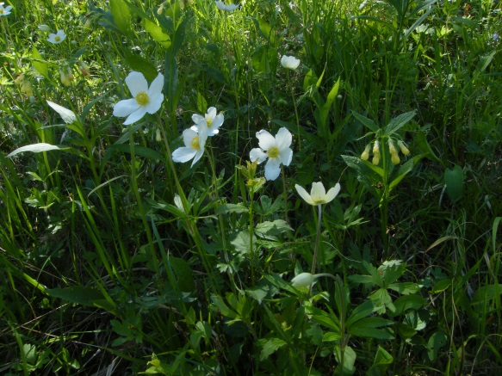

Most important was the discovery of several Clouded Apollos and a Southern Festoon which Andras found, and a sighting of another Tau Emperor moth. We saw our first of many Painted Ladies, feeding up on the flowering Buddleias in the gardens, and wondered if this was the vanguard of another great invasion by the stunning migrant butterfly.
We had our picnic in the village and after a look in the church, wandered through more lovely flowery fields and the ancient graveyard with the old wooden carved grave markers cast aside at random. Other insects seen included the bright blue-black Dor Beetles, several Field Crickets, and Paper Wasps Polistes gallicus. On the way home we went to buy provisions at Ferencs’ smart new ‘discount’ shop in Szögliget.

Friday May 8th
It was a 6.30am start for the birdwatchers and we went up the track beyond Tornaszentandras. We were treated to a feast of birdsong, and with wonderful views of Golden Orioles, River Warbler, Red-backed Shrikes, Cuckoo, Yellowhammer and Hawfinch, and with Whitethroat, Willow warbler, Stonechat, Turtle Dove, Raven and Jay heard but not seen. We also saw a squashed Agile Frog, Rana dalmatina.

After breakfast we went with Istvan to look at Tornaszentandras Church. He told us a little of the history, the art and symbolism of the place. We also found good butterflies and a huge patch of comfrey that was awash with bees, including the huge solitary Violet Carpenter bee and Early Bumblebees, Bombus pratorum. There was a Red Squirrel in the trees by the churchyard and the butterflies included Common Blue, Wood White, Clouded Apollo, Scarce Swallowtail, Painted Lady, Pale Clouded Yellow, Greenveined White and Peacock; also a Silver Y moth. There were Beeflies, Bombylius major, Field Crickets, Roman Snail, Hornet, and Harlequin Ladybirds in huge numbers in the church.

We collected our picnic from Eszter and drove on to Martonyi Monastry stopping first at the Rakaca lake where there is masses of the invasive shrub Amorpha. A few birds there including Common Tern, Great Reed Warblers singing and showing well, and Great White Egret. Butterflies too: Sooty Copper, Wood White and Grizzled Skipper.
We stopped a little up the road to look at the herd of Hungarian Grey cattle and their calves, where we heard Fire-bellied toads and one Green Toad calling. Broadbodied Chaser dragonflies, Libellula depressa, flitted about on the muddy pools.

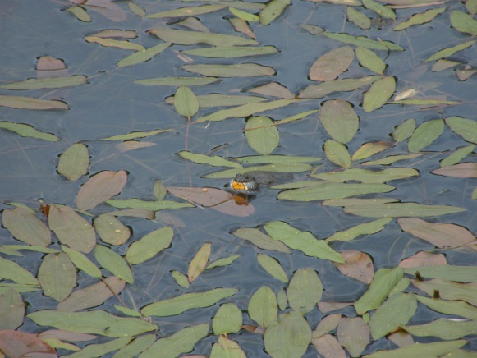
We had an unscheduled surprise journey up to the top of the TV mast hill above the old monastery followed by a picnic on the edge of the fields with a wonderful view southeast. There was a Quail calling, Wood White, Common Blue, and Chequered Skipper butterflies; Common Heath and Speckled Yellow moths and the pretty black and white Pyralid micromoth Anania funebris, and more of the large rove beetle Staphylinus erythopterus.

We walked up through the beech and hornbeam woods to the partly restored Paulian monastery spending a large amount of time looking up into the trees trying to pinpoint the calling Collared Flycatchers and the equally tantalising Woodpeckers (which we decided were probably Greater Spotted). We found a different Mistletoe called Loranthus europaeus and there were lots of Duke of Burgundy butterflies in a sunny glade below the ruins. We heard Black Woodpecker and Cuckoo calling.
Nigel put the moth trap out this evening; it was a clear night until the sky clouded over in the early hours and it started to rain from about 6am; minimum temperature 6.4’C.

Saturday May 9th
We spent some time before breakfast looking at the catch which included a few different species – Dewick’s Plusia, another Silver Cloud (Egira conspicillaris), Eyed and Small Elephant Hawk-moths, Dark Spectacle, Pale, Swallow, Coxcomb and Pebble Prominents, the lovely Orache moth, Puss Moth, several Pale Oak Beauties, and Kathy’s favourite, the Purple Cloud.

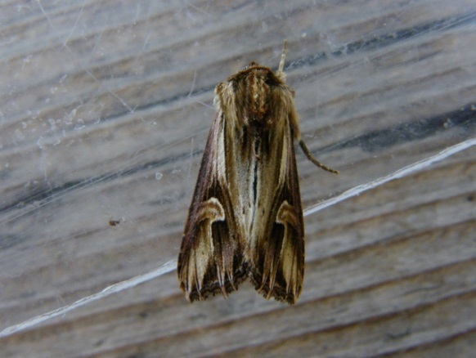

Later we went to the fields above Szin where from a distance we watched some gypsies cuttinoff Hawthorn branches and stripping the flowers off. Apparently this is normal gypsy practice and they dry the flowers to make tea.
Wonderful Toothed, Military and Lady Orchids and a huge diversity of flowers covered the slopes including Pasqueflower and Snowdrop Windflower. Birds seen from there included a Black Stork, Marsh Harrier, Skylarks in song.
Good butterflies and moths too: Glanville Fritillary, Woodland Ringlet, Pale Clouded Yellow, Wood White, Green-veined White, Grizzled Skipper, Common and Latticed Heath, and Speckled Yellow moths.

We had a picnic near Miklos Horthy's bear cage and had a brief wander in the woods.

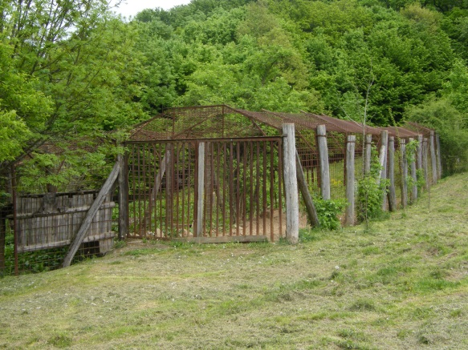

We watched two Honey Buzzards above us and the Horse Chestnut blossom alive with bees, including the Tree Bumblebee. Again we heard the tantalising song of the invisible Collared Flycatchers and watched a Nuthatch visiting its nest in the clay-lined hole in an old oak. Comma butterfly was an addition to the list.

Most people then walked the wonderful (well-marked) track to Derenk, and the rest of us drove to Szögliget and walked to meet them. Derenk was abandoned when the Polish inhabitants were forcibly removed by Horthy in 1943 to enable him to have a hunting park cleared of people.
The walk up the forest track towards Derenk from Szögliget was just as full of interest (not long ago this was a well-used route but became cut off when a large part of northern Hungary was ceded to Slovakia at the treaty of Trianon after WW1).

Butterflies seen this afternoon: Scarce Swallowtail, Red Admiral, Painted Lady, Comma, Duke of Burgundy (watched laying on Yellow Pimpernel which like the usual larval foodplants Cowslip and Primrose, is a member of the Primulaceae family), Chequered Skipper, Speckled Wood, Small Pearl-bordered Fritillary, Dingy and Large Skippers, Eastern Short-tailed Blue.
Birds: alba Wagtails, Tree Sparrow, Red-backed Shrike, Long-tailed Tit, nesting Ravens, Black, Green and Grey-headed Woodpeckers, Wood and Bonelli’s Warblers.
Others: Sand Lizard, Jumping Spider, Paper Wasp, Badger poo, Wild boar skulls, bird poo full of Common mistletoe seeds, Alternate-leaved Golden Saxifrage.
And most importantly, Dorothy’s MAGNIFICENT Carpathian Blue keeled Slug.

The group walking up from Szögliget had to run the gauntlet of groups of archers of all ages along the track, with long bows and cross bows. They were based at the Szalamandra Haz hostel for the weekend and were ‘hunting’ plastic, not-quite-life-size models of bear, wolf, wild boar , red deer etc. All very surreal!

In the garden of the Malomtanja Guesthouse today, we saw a Kingfisher and heard a Wryneck and a Quail nearby.

Sunday May 10th
An early walk up to Szadvar Castle above Salamandra Haz. It was a steep climb but the views from the top were wonderful particularly as the mist was still lingering below.
Good birdsong: Long-tailed Tit, Wood Warbler, Collared Flycatcher, our first Wren of the trip (!), Black Redstart, Greater Spotted Woodpecker, Nuthatch and Jay and two early rising Painted Lady butterflies.
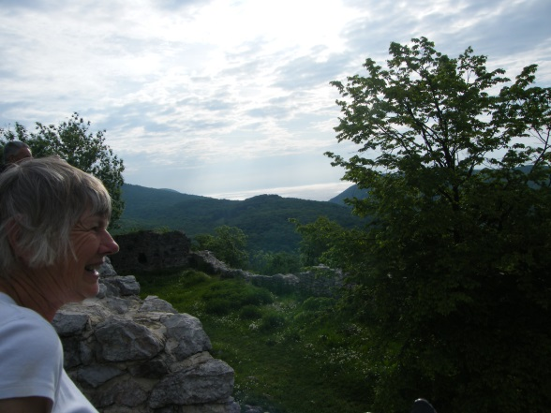

After breakfast we went to Galvacs to an old quarry where we hoped to find Bee Eaters. Sadly none were there but we did find a huge group of Large Tortoiseshell caterpillars on a small narrow-leaved willow bush. Other species included: Adonis Blue, Woodland Ringlet, Small Heath, and Dingy Skipper. There was a dead Slow-worm and a wildboar’s leg….

We had lunch on the grass above the Vörös-Tö (Red Lake) cave and admired the lake below us which was alive with Fire-bellied toads. Apparently here they are both Yellow-bellied and Fire-bellied and the hybrids between them, all very confusing!
We saw Eastern Short-tailed Blue, Small Heath, Blue-tailed Damselflies, a Raft Spider, Duke of Burgundy, Large Skipper, Common Blue, and Woodland Ringlet. There were Cuckoos all around us, alba wagtails and Blue Tits. Istvan identified the fish in the water as Roach, and as well as the Bombina toads, we saw a large Common Toad, several Green Frogs and a dead Grass Snake with a (dead) frog in its mouth.
The walk through the cave took 2.5 hours! The commentary by the Hungarian guide was ably translated and embellished by Istvan our personal cave guide.
On the way home we saw a Red Fox, a Brown Rat and a Hare.

Monday May 11th
The 6.30 am birdwatching group visited the charming little village of Tornabarakony just beyond Tornaszentandras, and followed a track through some fields and back to the road. There was a Wryneck and Golden Orioles calling in the village, and Red-backed Shrike, Woodlark, Whitethroat, Great and Coal Tits, and a busy family of Tree Sparrows in the fields and bushes beyond it. The butterflies and moths were just waking up in the early morning sun – Sooty Copper, Small Heath, Woodland Ringlet, Wood White, Heath Fritillary, Eastern Short-tailed Blue, Painted Lady, Speckled Wood, Scarce Swallowtail, the ubiquitous Common Heath moth, Latticed Heath, Duke of Burgundy and Small Copper. And several lucky people got their first sighting of Common Glider butterfly, Neptis sappho. We also saw Red Deer.

Later we set off for Gömörszölös, the village in the western part of the Aggtelek National Park that has always had a reputation for political independence and has recently been the centre of a generously funded sustainability project (now moderately defunct it seemed).

We stopped on the way at the Tourist shop by the entrance to the great Baradla caves at Aggtelek village to buy cards, T shirts and other souvenirs. There we saw Silver-studded Blue, Chequered Blue, Woodland Ringlet, the dark beefly Anthrax sp, a Common Toad and a Red Squirrel.

In the village of Kelemer we heard several Great Reed Warblers.

In Gömörszölös, we met Judit, the daughter of our friend from previous visits, the wonderful Laci Bácsi (= Uncle Laszlo); she helps to look after the folk museum there. We had our picnic in the garden and looked at the exhibits, with an interesting introduction to the village from Judit, again beautifully interpreted by Istvan. Then we went to look at the huge hoard of items in Laci Bácsi’s house/museum and he showed us his landscape paintings and his late wife’s lovely woven and embroidered linen goods. We parted having shared some very good pálinka. We failed to buy Eszter a nice Hungarian woolly jersey despite seeing a pile of them in the shop as no one seemed to have a key to the store! Some of the group walked up the track towards the old vineyards and orchards where Angela was attacked by a rabid Ground Beetle, Carabus arvensis. Its bite seems to have caused no longterm effects.

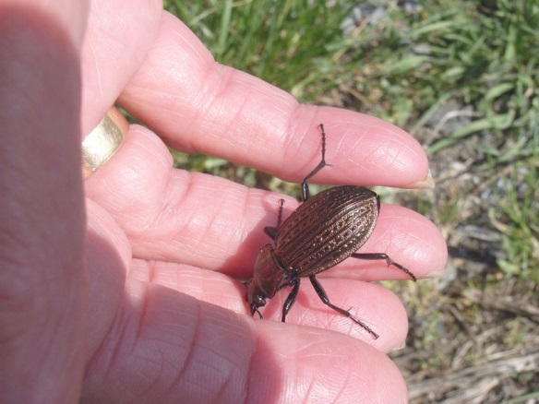

Butterflies: Scarce Swallowtail, Small Heath, Brimstone, Comma, Heath Fritillary, Woodland Ringlet, Pale Clouded Yellow, Large White (our first of the trip), Green-veined White, Chequered, Dingy, and Large Skippers, Orange-Tip, Peacock, Speckled Wood, Map, and Yellow-legged Tortoiseshell. There were Shrill Carder Bees, Bombus sylvarum (rare in the UK) and the little solitary bee that lays in empty snail shells, Osmia bicolor.
Birds: Whitethroat, Song Thrush, Turtle Dove, Red-backed Shrike, Collared Dove, Whinchat.
Nice flowers: Toothed Orchid, Lady Orchid, Umbellate Star-of-Bethlehem Ornithogallum umbellatum.
We also saw a Green Lizard, a dead Slow-worm and a Red Fox.

We returned to Tengerszem above Jósvafő and met Sandor and Roland, our friends from previous visits and still employees of the National Park. Sandor explained a little about what was happening in the Park and some of the problems they had to deal with.

We returned to Komjati for another of Eszter’s delicious suppers washed down with Borsodi beer and Bulls’ Blood wine at 650 Forints (£1.53!) a bottle, with a chorus of Nightingales, frogs and crickets in the background – it was a hard life!

Tuesday May 12th
The early morning group went a little way beyond Tornaszentandras on the Tornabarakony road and walked up through the scrub into the forest, some planted, some alder carr. The highlight of the morning was the discovery of a calling Corncrake as we were leaving to return for breakfast, but we are fairly certain the other elusive bird singing near it and giving alarm calls when being harassed by Red-backed Shrikes was a Barred Warbler (which we heard again in western Hungary). We also heard Willow and Bonelli’s Warbler, Black Woodpecker, Cuckoo, Wryneck, Yellowhammer, Great and Marsh Tits, Chaffinch, Wren, Blackbird and Turtle Dove and saw a dead fox being rapidly recycled by beetle larvae, Fire-bellied Toad in the alder wood and another Potter wasp nest.
Gabor Sramko and Victor the botanist from the National Park arrived shortly after breakfast and 3 of the group went with them for a wonderful morning search for Thlaspi jankae, Slovak Pennycress, up on the ridge. It was a steep and hot walk/scramble, looking for specimens of T. jankae for Gabor to collect for DNA sampling. What an amazing view from the top! We also saw the endemic and very rare Torna Golden-drop, Onosma tornense and many good butterflies.
Nigel took the rest of the group to the lake near Dobodel village to look for Little Bitterns, but there was very little there – Great Reed Warblers, Cuckoo, Whitethroat and Green Frogs in song, several Grass Snakes, Broad-bodied Chaser dragonflies, a Hare, Red-backed Shrikes, Magpie and Firebugs. And at last we saw the first Swifts for the visit – three of them flying north. Where are they all?
After lunch Gabor took us to a very dry hill called Jona-hegy, at the eastern end of the Rakaca lake. It was more overgrown than he remembered but still had fantastic flowers including Green-winged Orchids, Orchis morio, the stunning little blue iris, Iris aphylla, the hawksbeard Crepis pannonica and the red-flowered bugloss, Echium maculatum.
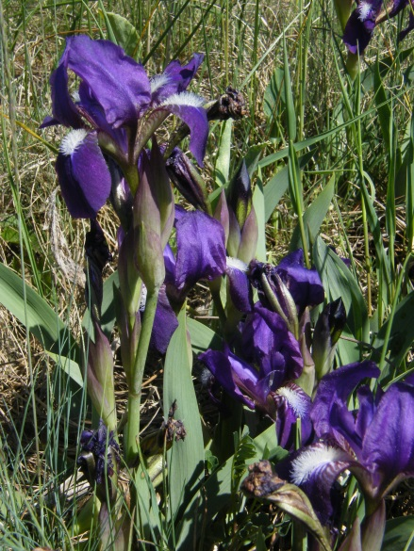
We also found the larva of Spotted Fritillary on mullein, Chequered Blue, Eastern Short-tailed Blue, Wood White, Glanvilles Fritillary, and a very dead black form of the Grass Snake. From the shore of the lake below we could hear Great Reed Warblers and a constant chorus of Fire-bellied Toads. Birds by the lake included Grey Heron and Buzzard.
Then Gabor took us to a wet area behind the village of Meszes nearby. We found a good variety of wetland plants but failed in our quest for the Bog Arum Calla palustris. We did see lots of other goodies, most importantly the Scarce Fritillary, Euphydras maturna, and the Southern Festoon, Zerinthia polyxena. Other species of butterfly: our first Mallow Skipper, Clouded Apollo, Comma, Small Pearl-bordered Fritillary, Large Skipper, Map and Painted Lady. As usual there were River Warblers trilling in what seemed every bush.
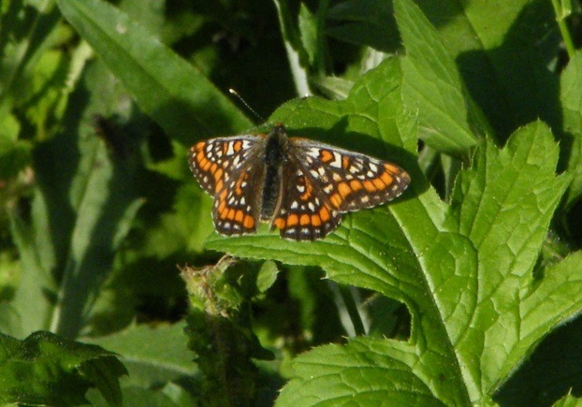
After supper Gabor gave us a fascinating presentation about his recent visit to Ukraine where he was on the quest of certain Pasqueflower species and the large sea-kale like Crambe tataria. After he had left us to drive home to Debrecen, we went up the valley to listen to the corncrake that we had heard in the morning. It did not disappoint us, but sadly there seemed to be only one.
Nigel put the moth trap out tonight.
Wednesday 13th May
We looked at the moth catch in the morning – not many new species – Snout, Buff Ermine, Lesser Swallow Prominent and Dog’s Tooth (the noctuid with hairy eyes!).
After breakfast we went to Jósvafő and walked up a lower path through the forest. For the butterfly people the highpoint was the pile of fresh pony poo on the track which had attracted a wonderful array of butterflies and some moths.
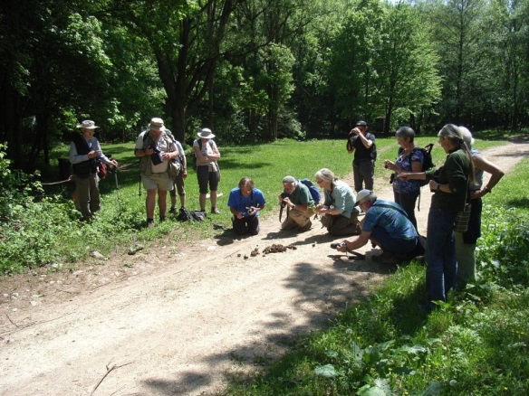
There were Large Grizzled, Grizzled and Chequered Skippers, a Map, several Silver-studded Blues, Holly Blue, Scarce Swallowtail and an Idas Blue which John photographed. There was also the black and white moth known as ‘The Pygmy’, Thyria fenestrella. About 60 Hucul ponies came past us on their way to the higher grassland. The large fast-flying Fritillary we saw by the stream was probably a High Brown; a group of young yellowhammers were having a bathe in the river and there were many little solitary bees drinking on the edge of the stream, probably a Halictus species. The brief flash of a small bright metallic orange butterfly was thought to be a Large Copper. We found a large Bagworm pupa, wrapped up in a bundle of debris.
We had a picnic by the National Park education and Hucul Centre again but had to make way for a group of happy and very well behaved children from a school in Budapest doing river dipping.
After, we walked up a steep wooded track just outside the village to the old vineyards. A wonderful diversity of flowers exists here but the best was a fine stand of Dragonshead, Dracocephalum austriacum.
The butterflies were superb: Green Hairstreak, Yellow-legged Tortoiseshell, Common Glider, Duke of Burgundy, Sooty Copper, Knapweed Fritillary, Burnet Companion Moth, Large Tortoiseshell.
Birds: Wryneck, Woodlark, Red-backed Shrike, Hobby, Black Woodpecker, Tree Sparrows.
We set up the moth trap under the cover of Joszef’s logshed as rain was forecast. In the event, it only started after dawn…and the temperature did not go below 9.8’C – so it was the best moth night of the stay.
Thursday 14th May
The moth trap had attracted a number of new species for our visit: Clouded Buff, Celypha lacunana, Burnished Brass, Brightline browneye, Bloodvein, Buff-tipped, Poplar Hawk-moth, Great Prominent, Doubleline, Mottled Rustic, Athetis lepigone (a dark noctuid with w white spot – not found in the UK), Ringed Carpet and the miocromoth Anania perlucidalis.The total moth species count for the visit is at least 87 which is fairly respectable considering how cold the spring has been. Slightly disappointing though that we haven’t seen the wonderful Giant Peacock Moth! Andras arrived in time for breakfast and spent the morning with us. He very kindly took a good part of the equipment back to his house for us to collect that evening.
Having packed and cleaned everything up we drove east to Bodvalenke, through the gypsy village with stunning paintings on the walls of the houses and beyond to the wet meadows we had surveyed in 2010. Sadly it was rather damp which hindered the search for Great Burnet, Sanguisorba officinalis, in the meadows. However we did get a superb view of a Hoopoe on the road verge, more Swifts, Marsh Warbler with its amazing mimicry, Sedge warbler, Reed Bunting, another Corncrake, more Quails, Common Buzzards and a distant raptor which could have been a Short-toed Eagle.
We returned to a delicious last lunch including cold cherry soup, one of Eszter's specialties and all too soon we had to bid them all farewell and clamber aboard for the last trip to Budapest. The 4 independent travellers left with a hint of glee to continue their holiday in the Hortobagy while the rest of us prepared for the return journey.
The train travellers were dropped at Keleti station in Budapest at about 6pm while John and Diana
walked to their guesthouse within view of Buda castle for their very enjoyable three day stay in the city. Nigel and Kathy spent one night with Andras and his family in Vác, just north of Budapest, explored some wonderful places close to Andras’ home, then drove to Fertö-Hánsag National Park on the Austrian border.

The happy end of the story is that the rail travellers reached St Pancras on time at 19.50 the following day after a comfortable and happily uneventful journey across Europe!

Nigel Spring and Kathy Henderson May 30th 2015

