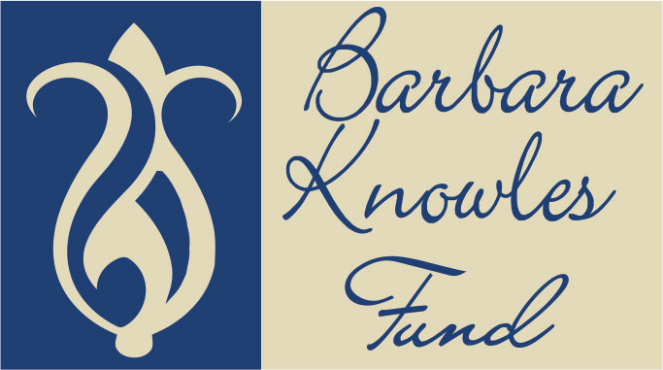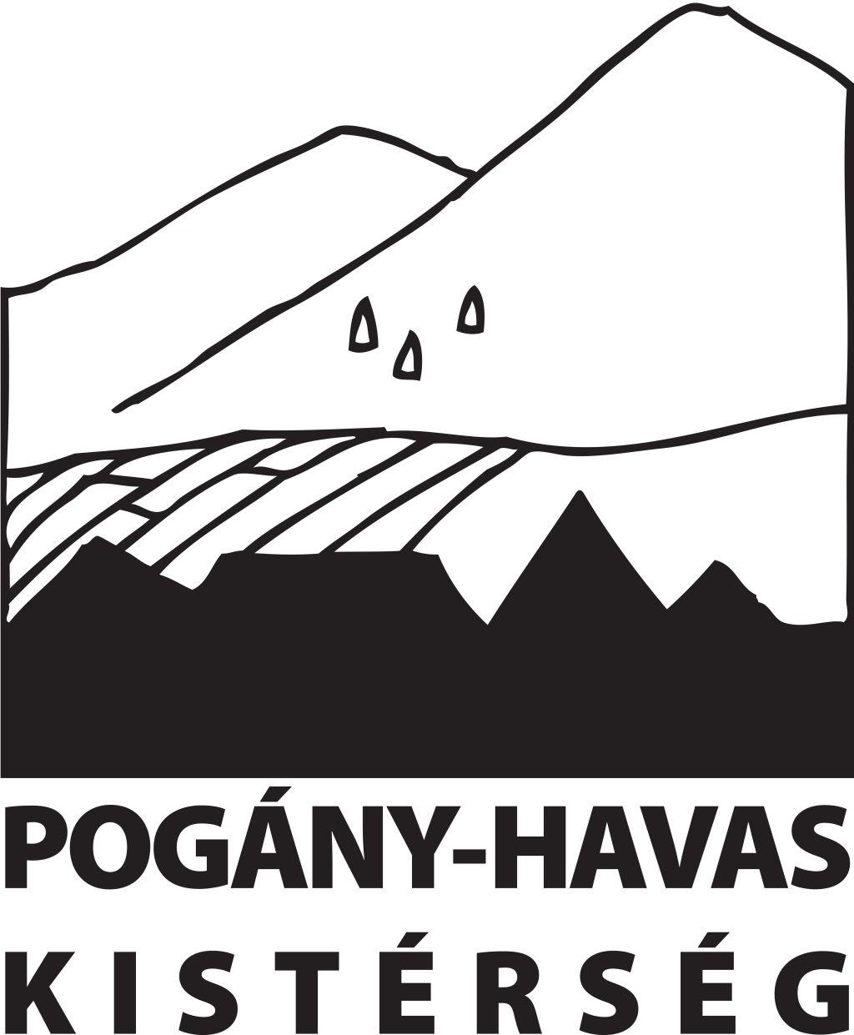

International hay making camp in Gyimesbükk
Transylvania, Romania
9-16 August 2015

Booking form

Thank you for your interest in our haymaking camp.

To confirm your booking, please complete this form and return it to Robert Biro (biro.robert@poganyhavas.ro).

Please also send us a deposit of 15 EUR/ £15 per person to secure the booking. We are asking for a deposit because there has been a lot of interest in this camp and we want to be certain that this interest will result in actual visitors.

In order to save on overseas money transfer fees, you can give us the deposit in the form of a donation to our projects at www.justgiving.com/barbaraknowles (describe it as “hay camp donation”), and if you are a UK taxpayer please consider increasing the value of this donation through gift aid. If you prefer a bank transfer, let me know and I can give you the details of a euro account in our Romanian bank.

You can pay the balance of your accommodation, food, any extra excursions etc. by cash in pounds, euros, or Romanian lei at the end of the camp, or via the justgiving website.

If we are arranging the airport or railway pickup for you, please make sure you give us a mobile phone number which we can use to reach you when you arrive in Romania, for example if your driver is delayed. We will send you the contact details of the person who will be collecting you, so you can inform them if your plane or train has been delayed. Or for any other urgent enquiries you can call
00 40 724 494 983.

Booking details:
1. Name of each person in your party (given name, family name, and the names and ages of any children in the party)

2. Date of arrival

3. Date of departure

4. Would you like us to collect you from an airport or railway station? If so, please supply full details of when and where you will be arriving and departing, and flight numbers if relevant. (If you have not yet booked your transport, you can send us this information later)

5. Mobile phone number which we can contact you on when you arrive in Romania

6. What sort of accommodation do you require?

a) Basic village accommodation; very close to the camp site. This will usually be a shared room with shared shower and toilet facilities in a small village guesthouse or private home. Cost: €40 or £30 per person per day full board. This includes meals with the hay camp group.
b) If you prefer to bring your own tent, we can provide space and access to toilet and bathing facilities for €5 or £4 per day, plus all meals for €30 or £20 per person per day full board as in option a).

7. Do you have any special dietary requirements, or any other requirements?

8. Would you like us to provide a local guide for additional tours of the region before or after the camp? This can be arranged for approximately €50 per day, to include the guide and petrol costs. This is a highly recommended option, and can be tailored to your interests. If you are interested, please tell us which days and what sort of things you would like to see and do.

9. We hope to use this event is to learn from each other, so please come prepared to tell us something about your own region or activities through words, pictures, objects, demonstrations or short film clips. We will use the evenings of the camp to exchange information informally like this.

If you have any questions please contact Robert Biro (biro.robert@poganyhavas.ro).

To read more about the region, you can download our brochure http://www.poganyhavas.hu/menu.php?menu=turizmus&almenu=12&lang=en

Organizers: Sárig Attila and Pogány-havas Association.
Supporters: Barbara Knowles Fund.

